E-COMMERCE CART SYSTEM BY CHARU TAMAR

A startup, ShopEase By Charu , is a simple shopping cart system that allows users to:

● View available products fetched from a backend API

● Add products to their cart and manage quantities

● Remove items and view a dynamic total price

● Proceed to checkout with a validated form

● Receive an order confirmation

**User Story 1 - Products displayed dynamically using Axios from a JSON server.**

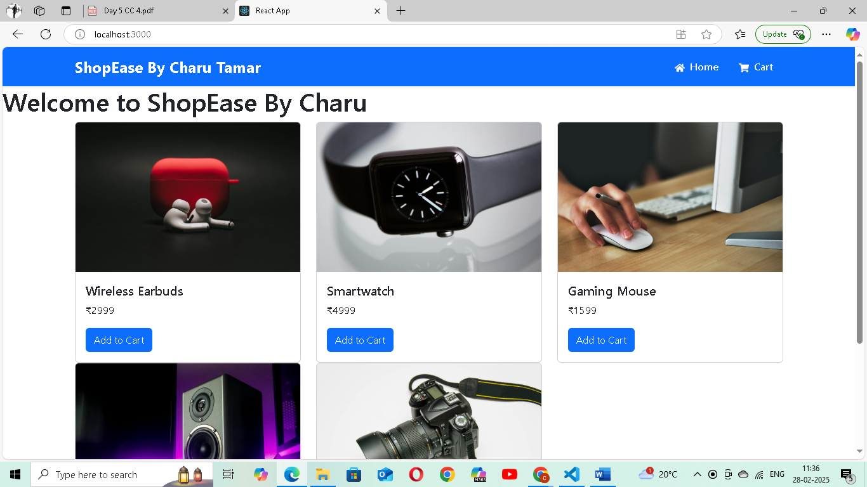

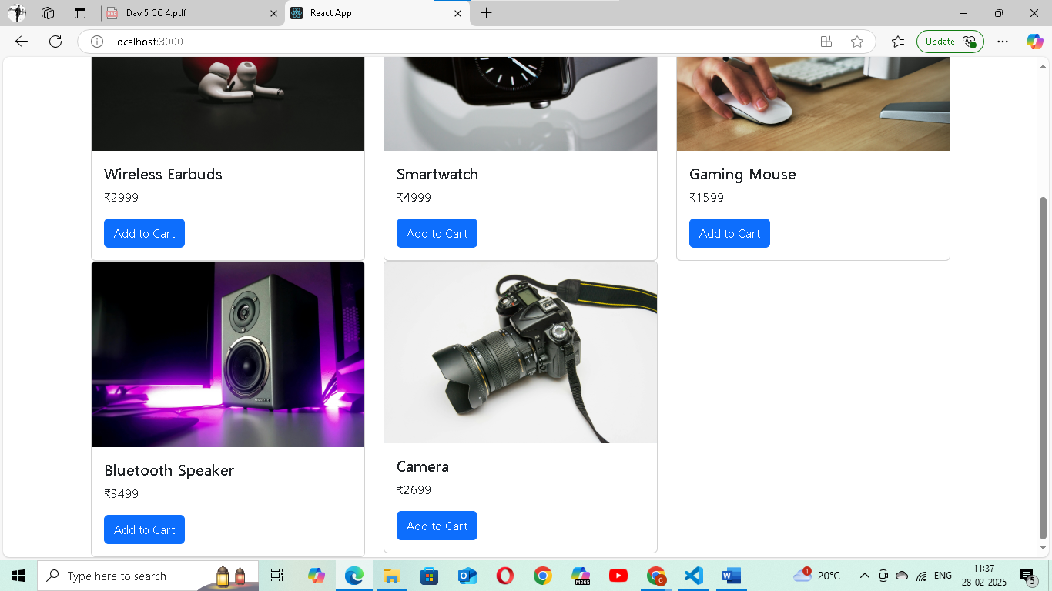

**USER STORY -2 Cart badge updating dynamically when add to cart button is pressed**

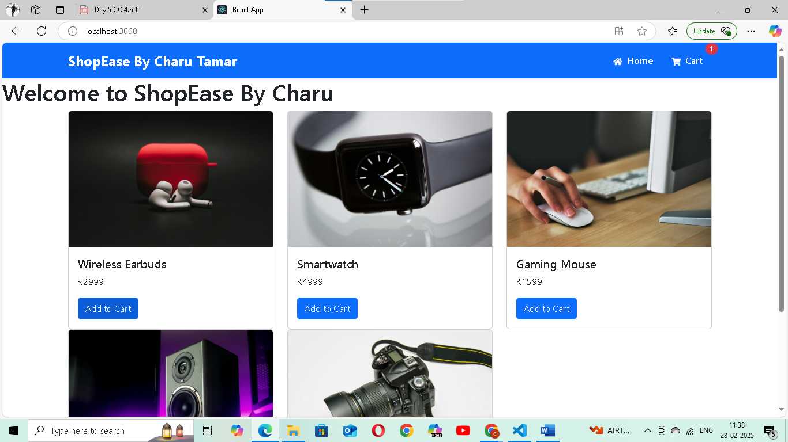

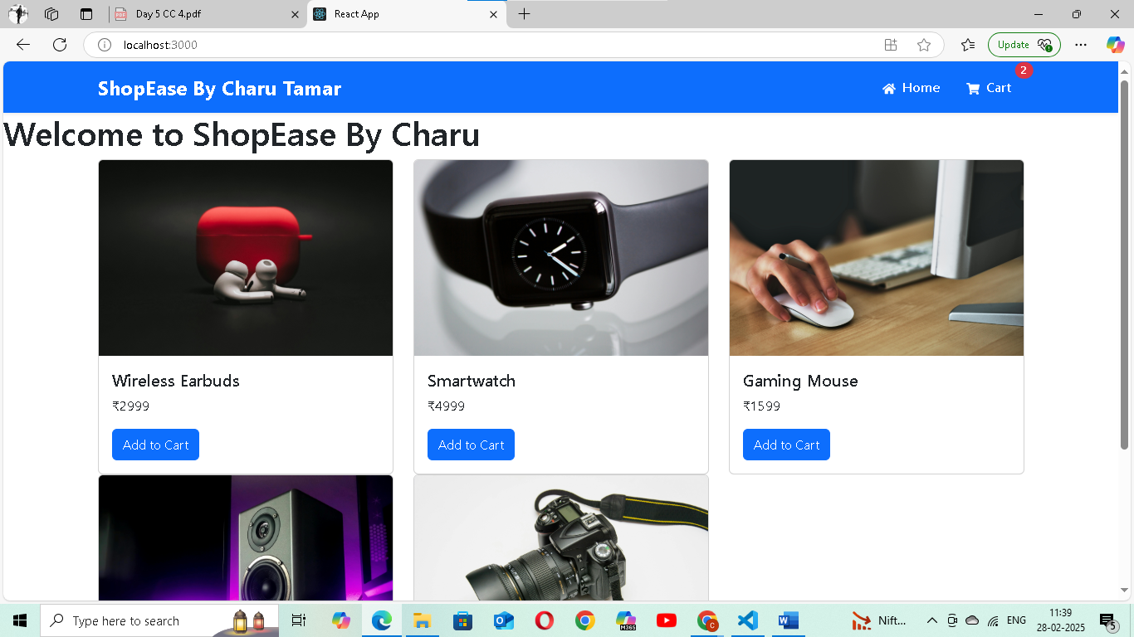

**USER STORY 3 – Displaying all selected products with accurate total price calculations.**

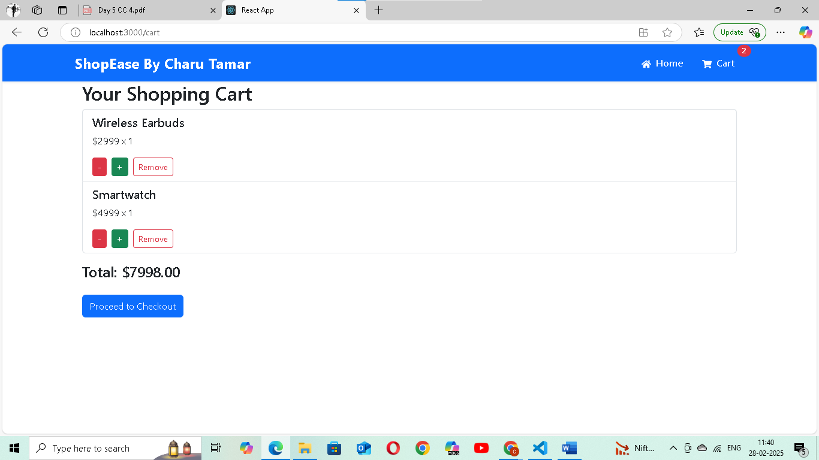

**USER STORY 4 – Quantity updates dynamically modifying the cart total.**

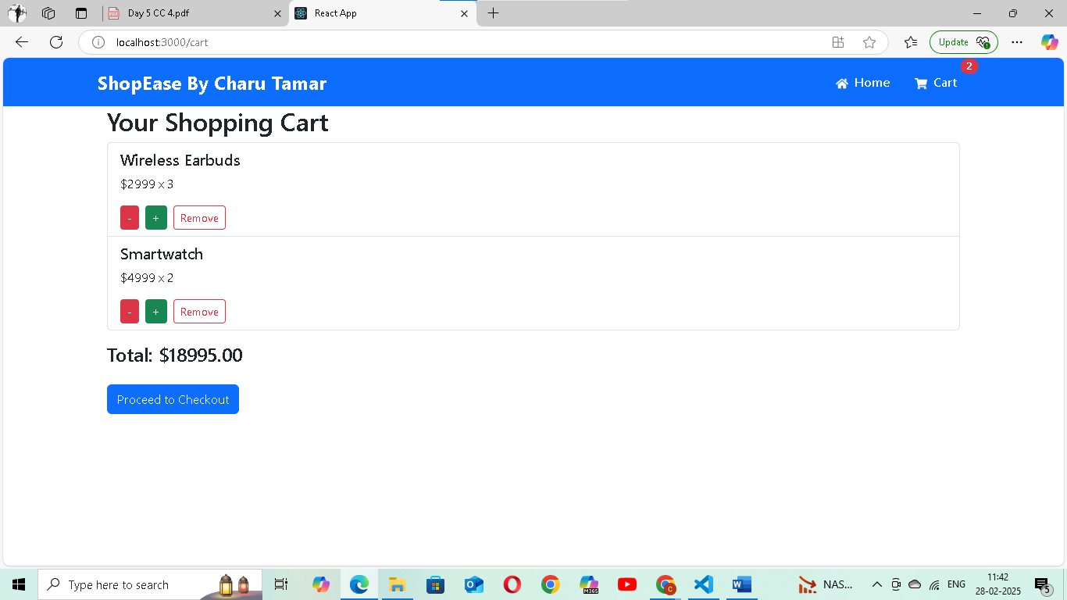

**USER STORY 5 – Can remove the item from cart and UI updated instantly**

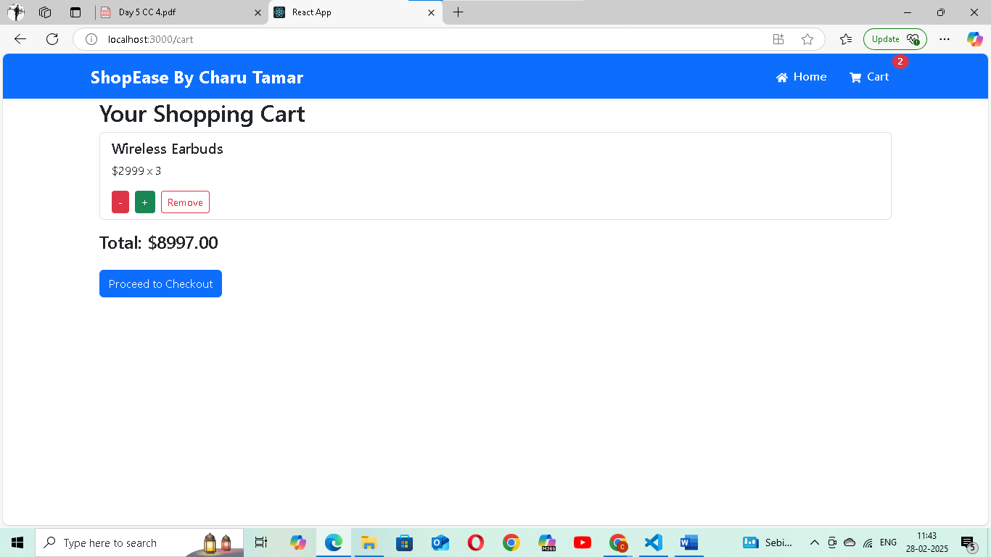

USER STORY 6- The checkout form is validating inputs using Formik and Yup before submission

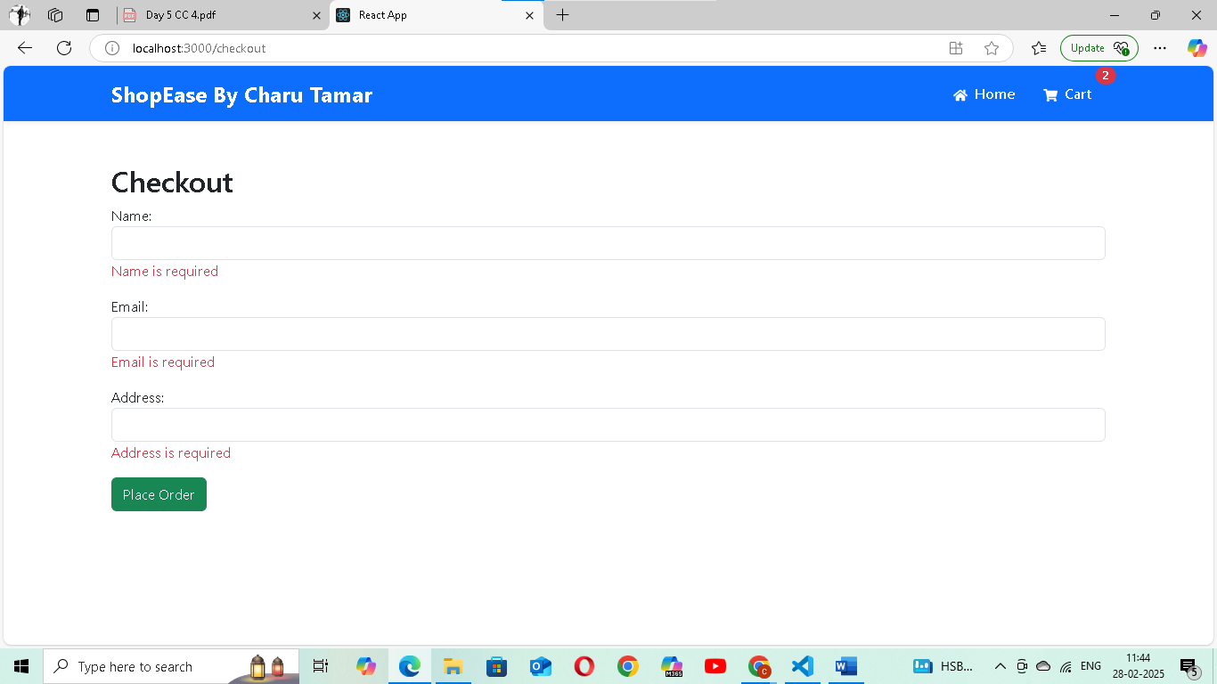

**USER STORY 7 – After adding all the details we are redirected to confirmation page**

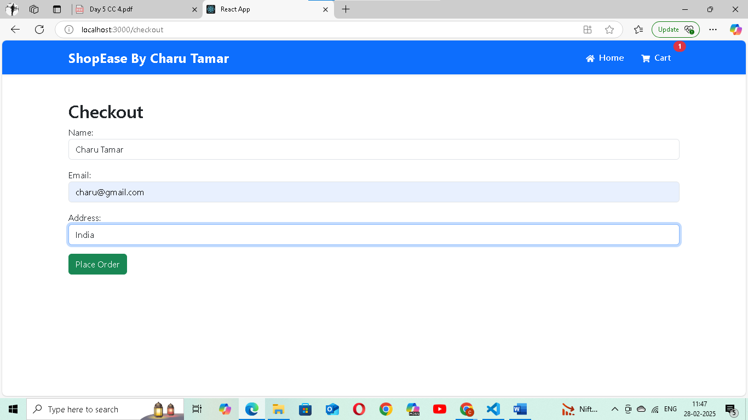

**USER STORY 8- Navigation handled using React Router**

**ORDER CONFIRMATION PAGE:**

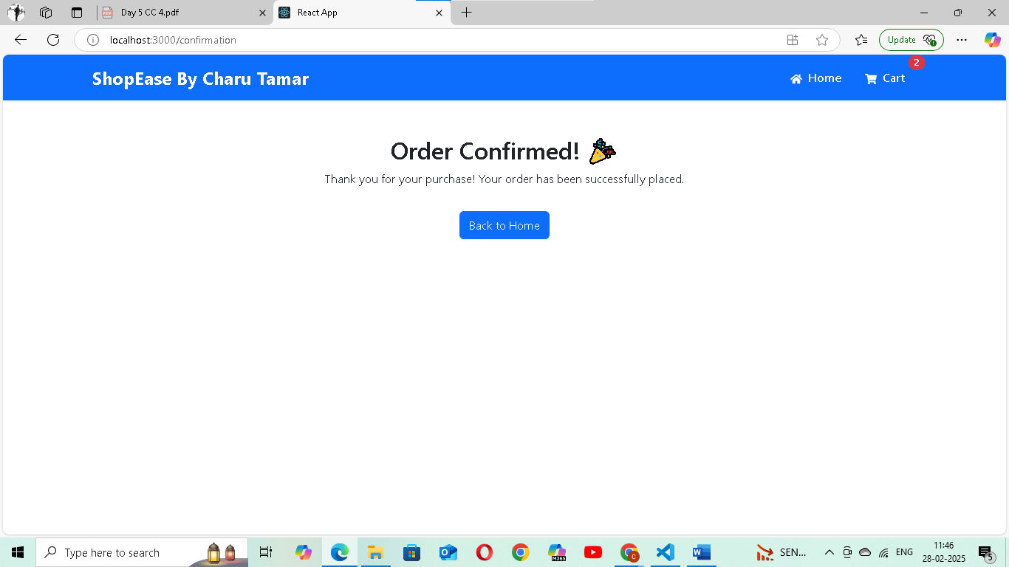

**FOLDER STRUCTURE:**

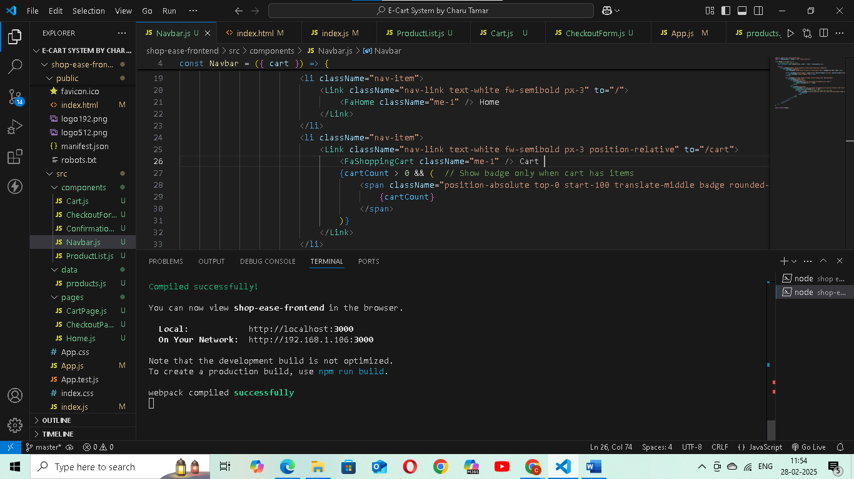

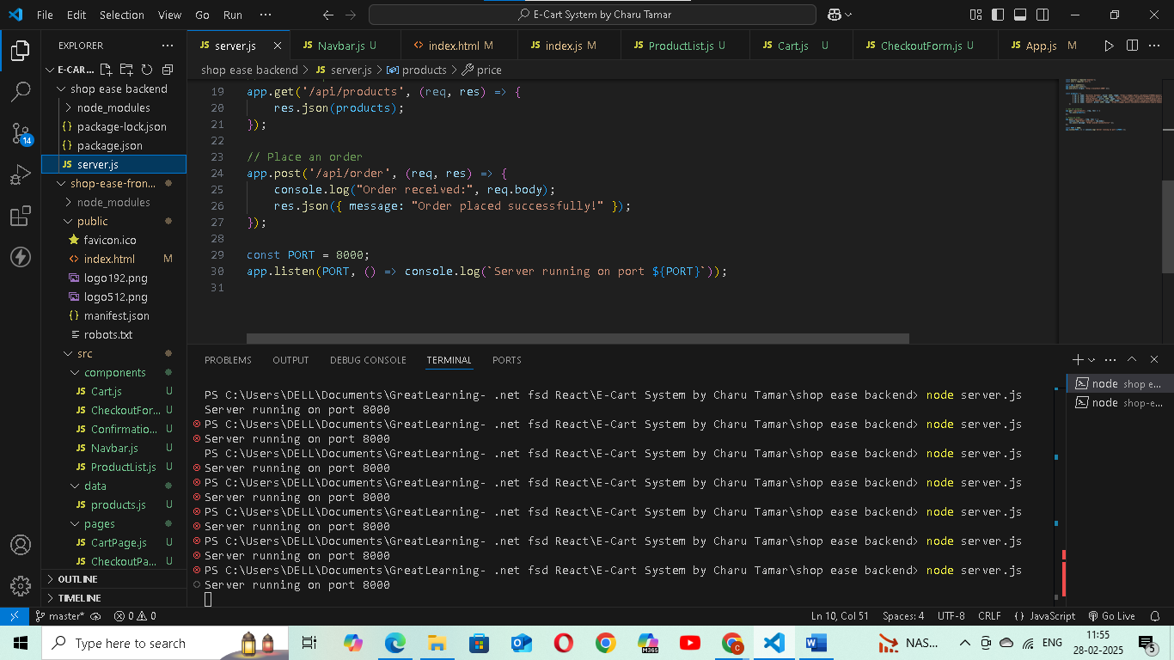

const express = require('express');

const cors = require('cors');

const app = express();

app.use(express.json());

app.use(cors({ origin: "http://localhost:3000" }));

const products = [

        { id: 1, name: "Wireless Earbuds", price: 2999, image: "https://images.pexels.com/photos/3780681/pexels-photo-3780681.jpeg" },

        { id: 2, name: "Smartwatch", price: 4999, image: "https://images.pexels.com/photos/437037/pexels-photo-437037.jpeg" },

        { id: 3, name: "Gaming Mouse", price: 1599, image: "https://images.pexels.com/photos/392018/pexels-photo-392018.jpeg" },

        { id: 4, name: "Bluetooth Speaker", price: 3499, image: "https://images.pexels.com/photos/2651794/pexels-photo-2651794.jpeg" },

        { id: 5, name: "Camera", price: 2699, image: "https://images.pexels.com/photos/51383/photo-camera-subject-photographer-51383.jpeg" },

    ];

// Get all products

app.get('/api/products', (req, res) => {

    res.json(products);

});

// Place an order

app.post('/api/order', (req, res) => {

    console.log("Order received:", req.body);

    res.json({ message: "Order placed successfully!" });

});

const PORT = 8000;

app.listen(PORT, () => console.log(`Server running on port ${PORT}`));

import { useEffect, useState } from "react";

import axios from "axios";

const ProductList = ({ addToCart }) => {

    const [products, setProducts] = useState([]);

    useEffect(() => {

        axios.get("http://localhost:8000/api/products")

            .then(res => {

                console.log("Fetched products:", res.data);

                setProducts(res.data);

            })

            .catch(err => console.error("Error fetching products:", err));

    }, []);

    return (

        <div className="container">

            <div className="row">

                {products.length === 0 ? (

                    <p>No products available</p>

                ) : (

                    products.map(product => (

                        <div key={product.id} className="col-md-4">

                            <div className="card">

                                <img src={product.image} className="card-img-top" alt={product.name} />

                                <div className="card-body">

                                    <h5>{product.name}</h5>

                                    <p>₹{product.price}</p>

                                    <button onClick={() => addToCart(product)} className="btn btn-primary">Add to Cart</button>

                                </div>

                            </div>

                        </div>

                    ))

                )}

            </div>

        </div>

    );

};

export default ProductList;